Drama Lesson Portfolio
Grade level: Grade 6
Theme: Space and body awareness.
Title: The Dragon Tail

TEKS:

TEK: 116.2a. Science

Children in the K-2 grade study essential movement skills and start to understand how different organs of the body function, such as the lungs, heart, bones, and muscles, and they gain knowledge through bodily action. Pupils start to develop language movements that relate to learning space and body awareness by applying different ideas. Students are involved in actions that cultivate basic stages of power, strength, and flexibility. Students are also able to develop movements individually and in groups. The activity's main goal is to introduce actions that are challenging and enjoyable in their natural disposition in physical activity. (1) Movement: The student develops proficiency and expertise in different exercises related to the topic of study.

Art TEK: §117.2b. Theatre

The student is supposed to make different movements, including high, low, and medium, which will demonstrate his or her individual and overall awareness of space. Students will be provided with scarves to tuck into their shorts and leave three-quarter of it hanging outside. The game will be about who catches the most tails. The student will initiate several movements such as jumping, bouncing, hopping, dashing, and slipping as they try to see and grasp as many scarves(tails) from their colleagues.

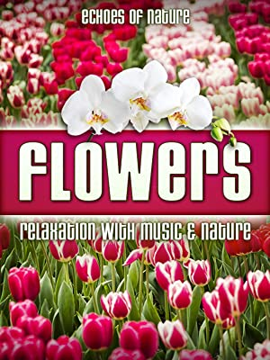
- CD:

I choose the CD 'Flowers relaxation with music and nature' by Liam Dale. I will play music to help students concentrate and have more energy as we generate different movements. The music will give them more strength. The theme also contains beautiful melodies about nature, and it is relaxing and peaceful. The piece will also be essential in monitoring the student who has caught the highest number of tails.

Movements
Children will be expected to walk fast after turning the music on, then skip, gallop and run on their boundaries and try to get hold of many tails as possible without losing theirs. One hoop is placed at the corner at each of the four corners of the activity floor. When you catch a tail of a scarf, place it inside the hoop by running it over. Covering the scarf using hands does not prevent it from being snatched by the others. If your tail is grabbed, run and get another one. The game will stop when the music is turned off, and we will identify the student with the highest number of tails. Then the game will start over again when the music starts to be played.

Template of the Lesson Cycle
A leak up to remind students of the previous lessons that involved the body's organs' various functions. | I will assemble my students into one large group and ask them, 'who can remember the major functions of the lungs, heart, and muscles and the lessons we learned last week?' .' Who can be able to create body movements that will involve the movement of muscles and accelerate the rate of the heartbeat?' Once they can give correct answers, I will guide them on the functions of the organs and muscle movements that will increase the heartbeat rate and describe why it is essential.
Topic | I want us to study the heart's major function, which is pumping blood, as I had earlier said. We will do this by making movements using our whole body and feel the heart beating faster.
Teach and demonstrate | I will ask each of the various movements that increase the heartbeat rate; once they mention, I will demonstrate depending on the activity. I will also ask them to make the movements as they imitate whatever I do. Then I will play the music CD and ask them to reflect on the major function of muscles and the heart. I will also ask them to create other desired movements to increase the heartbeat rate apart from what I had demonstrated to them. They will actively engage themselves in the activities even after dismissing them into their classrooms carefully without hurting others.
A review of the lessons to test understanding | I will ask students to show us the movements they created on their own and review what we had learned last time. It will test the understanding of the role of the heart and muscles.

Visiting Artist: Shara Phillips

I will contact Shara Philips, a proficient dancer, to join me in the lesson and help my students create different movements. They will start slowly and then increase the speed faster. She is an instructor who has trained in a variety of dance and makes the right dance moves. She is a Bachelor's degree holder of Fine Arts from Sam Houston State University. Shara has been teaching dance for several years; hence I believe she will be a perfect fit to teach my students whole-body movements. The students will also be able to learn dance moves that increase the rate of the heartbeat.

Floorplan:
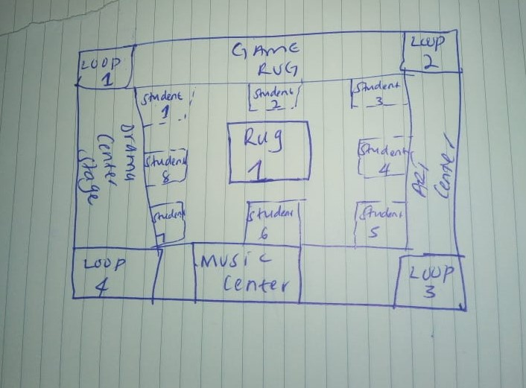

In this floor plan, I will allow students to play individually and then place them into groups to showcase their different movement skills across the boundaries set without moving out of the border. I will also provide them with scarfs materials to actively engage themselves in various movements and assist them in tucking into their shorts.
Purpose of the center
The center part aims to ensure that all students are actively engaged in the movements, and no student is left out. It will also enhance all the students and those on stage playing, and the observers since all of them will not fit on the stage hence will play in turns. They will be creative in adopting other dance moves that will enable them to get hold of tails without getting out of their boundaries.
The skills students will develop.
Creativity is one of the skills students will develop. They will use creative thinking to create movements. They will also build teamwork through collaboration by making group plays. Students will also gain communication skills by discussing the various actions they initiate.
Materials needed
Materials to be used include scarves, four hoops, a music player, and music.
Guidelines
- Students will listen and adhere to the teacher's instructions on how to make movements.
- Students will take care of the materials provided to them to avoid tearing of scarfs.
- Students will assemble the materials they do not need at the back to create space at the center.
- Students will attentively listen and follow the performer’s instructions.

Assessment
Assessment will test the students' understanding of the major functions of muscles and movements that increase the heartbeat rate. I will ask them questions related to the tasks as I play music on the CD. They will also imitate actions and make movements slowly and faster. I will award them points according to how they perform. For example, a student who will have more tails or grasped more scarfs will earn many points; it will be dependent on the number of scarfs. I will also ask them to create new movements they might have invented related to the various activities and earn extra points.

Student’s Name | Number of Tails | Extra points | Total | Groups | Number of Tails | Extra points | Total
1 |  |  |  | 1
2 |  |  |  | 2
3 |  |  |  | 3
4 |  |  |  | 4
5 |  |  |  | 5
6 |  |  |  | 6
7 |  |  |  | 7

